Typography and Web Fonts

Theory Assignment
Question 1: Explain the difference between web-safe fonts and custom web fonts. Why might you use a web-safe font over a custom font?
Ans: Web-safe fonts are the basic fonts that are already installed on almost all devices and operating systems—like Arial, Times New Roman, Courier New, or Verdana. Since they’re built into the system, the browser doesn’t need to download anything extra to display them.
On the other hand, custom web fonts (like fonts from Google Fonts or Adobe Fonts) are not usually installed on a user’s device. Instead, they are loaded from the web when someone visits your site. These fonts give you a lot more style and personality options, so your site can look unique and match your brand.
You might choose a web-safe font over a custom one for a few reasons:
- Faster Loading: Web-safe fonts don’t need to be downloaded, so your site loads faster—especially important for users with slow internet.
- Better Performance on Older Devices: Some older devices or browsers may not fully support custom fonts.
- No External Requests: Web-safe fonts don’t rely on outside services (like Google Fonts), so there's less chance of issues if those services are slow or blocked.
- More Privacy: Using only web-safe fonts means you’re not making extra requests to third-party servers, which can be better for user privacy and data policies.
Question 2: What is the font-family property in CSS? How do you apply a custom Google Font to a webpage?
Ans: The font-family property in CSS is used to set the font of text on a webpage. It tells the browser which font(s) to use for displaying text.
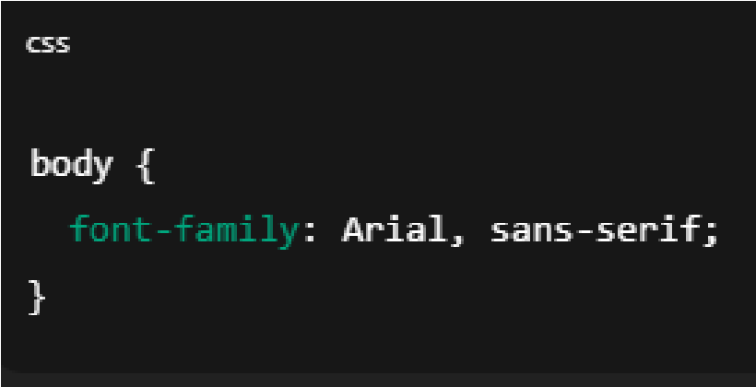
In this case, the browser will try to use Arial. If it can’t find Arial, it will fall back to a generic sans-serif font.
How Do You Apply a Custom Google Font to a Webpage?
- Step 1: Link Google Font in your HTML <head>
Go to https://fonts.google.com, choose a font, and Google will give you a <link> tag. For example, for the Roboto font:

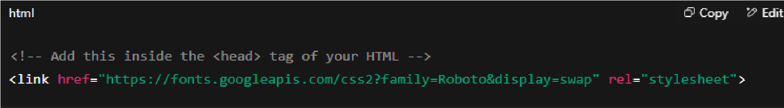
- Step 2: Use the font in your CSS
Now apply it using the font-family property:

